with outflow calculated from cell 9 (1-8C)

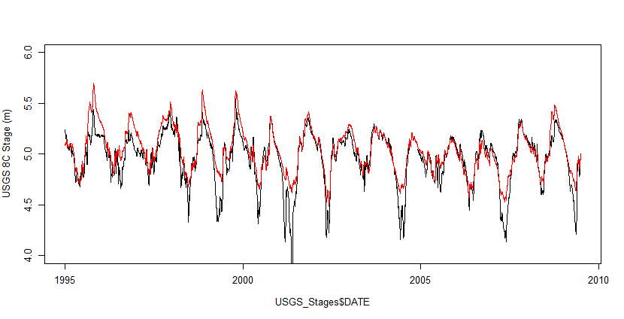

Outflow calculated from cell 5 (S10D)

